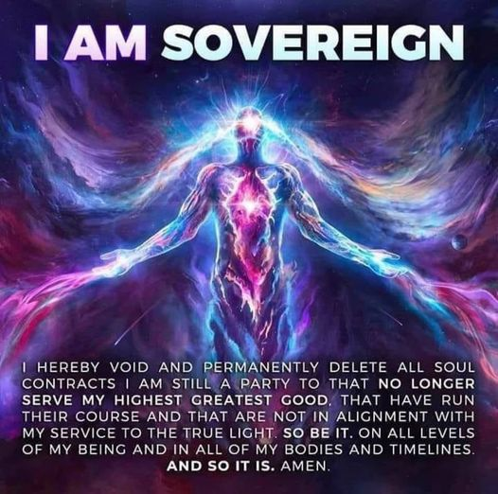

MARSICH CROWN PAREMATA MATAMUATANGA
​PERSONAL DECLARATION OF SOVEREIGNTY
All men and women are endowed by their creator 'God' with certain unalienable rights. It is men and women themselves who are solely responsible for securing these rights.

It is the right and duty of every man and woman to take on the responsibilities of self-governance. Strength in numbers and power of purpose alone will allow humanity to transcend the evolutionary constraints imposed on you by the operation of misrepresented governments and globalist institutions. Scriptures relating to Governments.

The Paremata Sovereign Nation Declaration of Sovereignty will enjoin the voices of men and women across matamuatanga 'our kingdom', across all cultural divides – putting all governments & globalist institutions on notice that it is they who serve the people and not the other way round, and that their services are no longer required.

Personal Declaration of Sovereignty

Be it known that I :Gavin-John:®©™℗, :Marsich:®©™℗, aka; :Ariki-nui-Kawenata:®©™℗, :Crown:®©™℗, of :Marsich-Crown-Kingdom:®©™℗, extend greetings to all races in the Greater Community of the Earth and Universe. I acknowledge our common heritage before the Creator of all the Universe, both visible and invisible. I affirm our core principles of consensus and common action, mutual respect, 'do no harm to another', inclusiveness, transparency, accountability, legitimacy, and responsiveness. I declare the planet Earth as humanity’s Planet of Genesis, my Kingdom, and our sacred inheritance. I pledge henceforth to sustain and preserve the Earth for all generations to come. I call upon all humanity to treat all races everywhere with wisdom and justice, here on Earth, throughout our Nation and throughout the Universe.

Fundamental Rights

Be it known that I, regard the need for freedom to be universal. Therefore, I hold that all individuals in all worlds are created equal and are endowed by the Creator with sacred and unalienable rights. Fundamental among these is the right to live as a free race on planet Earth; the right of self-determination, self-sufficiency, and creative expression; the right to life without oppression; and the right to pursue in life a higher purpose and a higher calling that the Creator has provided to all.

Before the Greater Community of the Universe, I do now invoke these fundamental rights for ourselves and for our Kingdom, along with certain rights that naturally derive from God, including:

- The right of sovereignty. The Sovereigns of Earth shall be self-governed and independent.
- The right of occupation. As the tribal people of plant Earth, we claim this Earth as our sphere of influence.
- The right of peaceful navigation. I claim the right to travel and explore this earth without interference or restraint from the alleged crowns corporations or its forces.

I consider it my rightful responsibility to assert and defend these fundamental rights, and to give and receive aid consistent with these rights.

I, therefore, do solemnly declare myself as a sovereign, to be free and independent; that I am absolved from all allegiance to the alleged capstone elite, crowns corporations and its forces, and that all political and economic connections between myself and them be totally dissolved; that as a free sovereign in the Greater Community of the Universe, I declare peace, levy war, contract alliances, establish commerce, and undertake all other actions which a sovereign shall rightfully and ethically do.

Concluding Statement

Let it be understood that in making this Declaration of Sovereignty, I affirm my future and destiny as a free sovereign within a Greater Community of intelligent life. I recognize that I am a part of this Greater Community and that I am destined over time to encounter many different races from beyond our world.

I hereby declare that my intention is not conquest or domination in space but to live with all sovereigns in conscious communities, peace, love, charity, clean, feed and teach. I declare that the rights and privileges that we affirm here are for ourselves.
​
In making my Declaration of Sovereignty, I proclaim my rights, responsibilities, and privileges as a sovereign in order that together, we may pursue greater unity, peace, and cooperation within the human family without unwanted or unwarranted intrusion and interference by any outside nation or force from the Greater Community. I make this proclamation as an expression of my Divine right and Honorable intent for the human family and for all races in the Universe who seek to be free.

Date: ____________
TOHU / MARK BY:

______________________________________________

WITNESSED BY:

- _________________________________________

- _________________________________________

- _________________________________________

Gazetted on Facebook, Twitter, Instagram, Other Social Media [Choose One or All]

Suv’eran Authority Notary Seal:

